Learn Hub (Online learning Platform)

A full-stack Online Learning Platform using MERN (MongoDB, Express, React, Node) enabling students to enroll in courses, teachers to manage content, and admins to oversee activity. Features include authentication, progress tracking, certification, paid/free courses, and a responsive UI. 📚 Online Learning Platform using MERN This project is a full-fledged Online Learning Platform (OLP) developed using the MERN stack—MongoDB, Express.js, React.js, and Node.js. It aims to replicate the functionality of popular e-learning systems by providing a dynamic and interactive environment for students, teachers, and administrators.

👨‍🏫 Overview The platform allows teachers to create, manage, and update online courses with multiple sections, while students can register, browse courses by category or name, enroll in free or paid courses, and track their learning progress. Upon completion of a course, students can download a certificate of completion. An admin oversees the platform, managing users and courses, and maintaining the integrity of the system.

💡 Key Features User Roles: Admin, Teacher, Student with dedicated dashboards

Course Management: Add, delete, update courses and sections

Progress Tracking: Resume learning, track modules completed

Authentication: Secure login and JWT-based authorization

Payments: Handle paid course access securely

Responsive UI: Built with React, Bootstrap, and Material UI

🛠️ Tech Stack Frontend: React.js, Vite, Bootstrap, Material UI, Axios, Ant Design

Backend: Node.js, Express.js, MongoDB, Mongoose

Authentication: JWT, bcrypt

Other Tools: Multer (file uploads), dotenv, nodemon

📁 Project Structure frontend/: React client app

backend/: Node/Express API and MongoDB integration

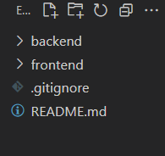

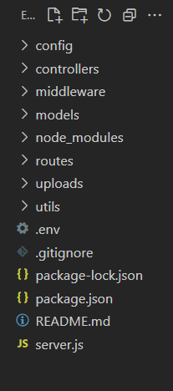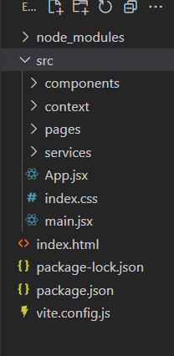

🚀 Setup Instructions Clone the repository

Install dependencies in both frontend and backend

Set up MongoDB and add .env variables (Mongo URI, JWT secret)

Start both frontend and backend servers

📌 Application Flow Student: Enroll, learn, complete, and get certified

Teacher: Upload and manage content

Admin: Full control of courses and users

This MERN-based OLP serves as a robust foundation for building real-world education

platforms, supporting scalability, modularity, and real-time interactions.

Git Hub:- <https://github.com/PRAVEENM282/OLP-Learnhub>